### **Documentation of Data Science Task**

### **Overview**

This report presents the findings and visual insights from a simulated logistics dataset, as part of the Uqaab internship practical test. The goal was to explore key operational metrics relevant to freight movement and decision-making using Python, pandas, and seaborn.

### **Tools & Libraries Used**

* **Google Colab** (Jupyter Notebook)
* **Python 3**
* **Pandas** – Data manipulation
* **NumPy** – Numeric calculations
* **Matplotlib / Seaborn** – Visualization
* **DataFrame Image (dfi)** – Summary table export (optional)

### **Key Metrics & Insights**

| **Metric** | **Insight** |
| --- | --- |
| **Average Shipment Distance** | 783.00 km – Moderate overall distance; supports cost estimation. |
| **Top 3 Frequent Routes** | Lahore ➝ Multan, Karachi ➝ Lahore, Lahore ➝ Islamabad |
| **Driver Utilization** | Some drivers show under-utilization; optimization potential exists. |
| **Most Active Origin Region** | Lahore – most shipments originated from this hub. |
| **Delay Rate** | 20.0% of all shipments experienced delays. |
| **Shipping Volume Pattern** | Balanced across weekdays; slight peak mid-week. |
| **Route Efficiency** | Wide distance range highlights potential for route optimization. |
| **Driver Idle Time** | Gaps between shipment dates indicate idle days for some drivers. |
| **Delay-Prone Routes** | Some routes show >30% delay rates, indicating reliability issues. |

### **Visualizations Summary**

The notebook includes 12+ charts that visualize trends such as:

* Most frequent origin-destination pairs
* Shipment distribution by region and date
* Utilization and idle time per driver
* Delay breakdowns by route
* Shipment volumes over time
* Distance distribution and route efficiency

**Examples of a few Charts**

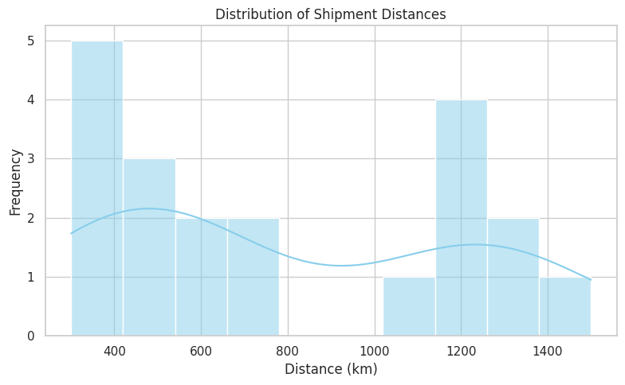

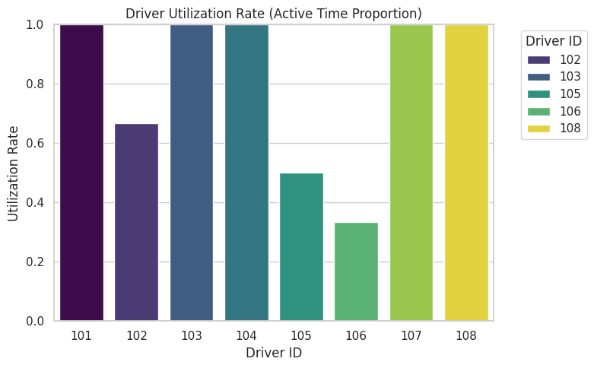

### **GitHub Repository Link**

[GitHubRepositorywithNotebook&Dataset](**https://github.com/FatimaRana50/algorizms-datascience-analytics-task/tree/main**)

### **Conclusion**

This analysis provides a strong starting point for building a logistics dashboard for Uqaab. With further data (e.g., real-time GPS, pricing, load weight), the platform can evolve into a smart freight-matching system that supports better routing, performance tracking, and predictive logistics.